A43-AM,S-Peru-Moche-Figurine-Male-Seated-100 BCE-400 CE

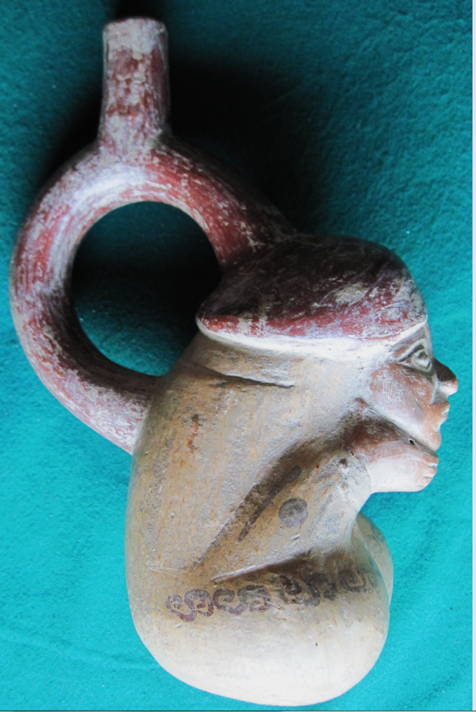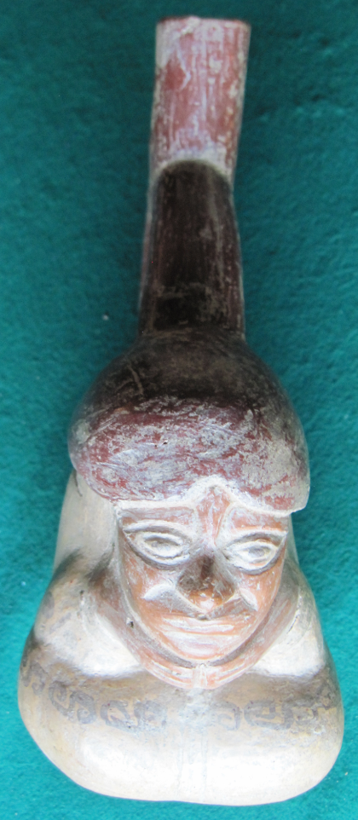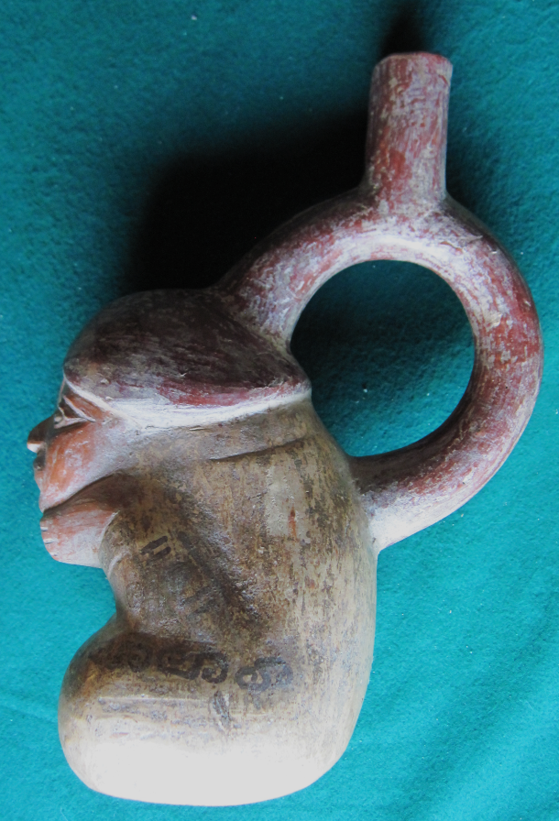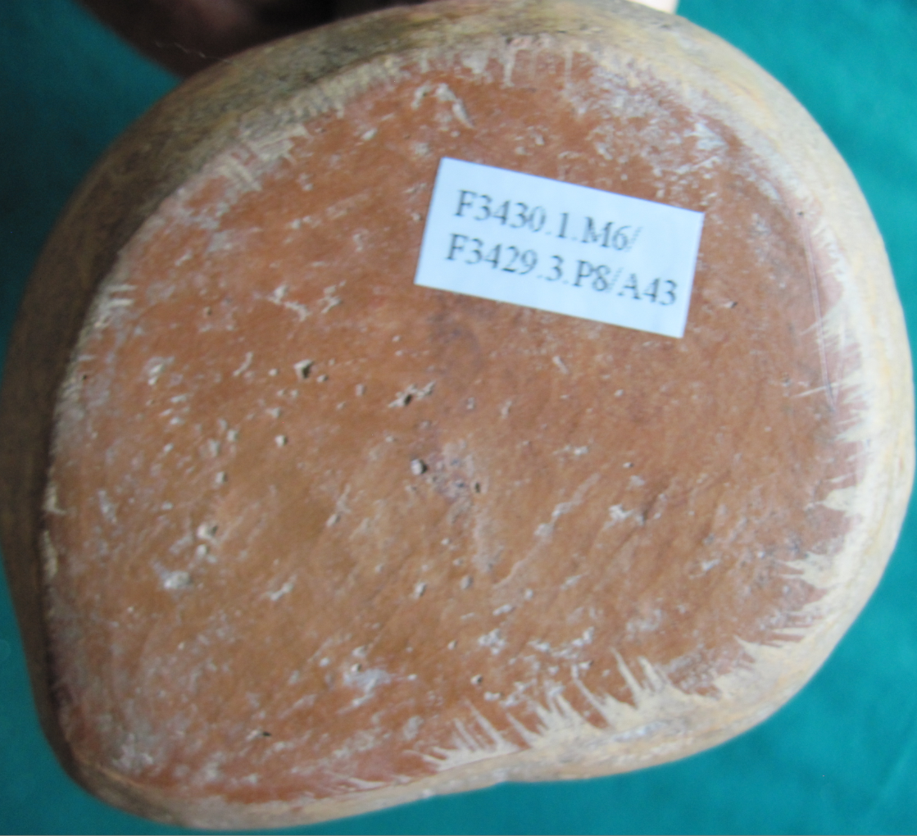

Figs. 1-4-AM,S-Peru-Moche-Figurine-Male-Seated-100 BCE-400 CE

**Case no.: 7**

**Accession Number: A43**

**Formal Label:** Peru-Moche-Figurine-Male-Seated-100 BCE-400 CE

**Display Description:** Moche figurine from the N Coast of Peru dating to the Mochica II Period, 100 BCE-400. Seated males may imply either they are captives or in this case with both hands under the chin perhaps a divining figure, however, both eyes are wide-open. This is, therefore, a rather enigmatic posturing. A series of tattoos or body paint runs the length of the upper thigh and on the lower arms, the purposes of which are not clear, but they may indicate a certain social position or status. He also wears a dull crimson bi-lobal cap which also may indicate his rôle.

AD/CE.

**LC Classification: F3430.1.**

**Date or Time Horizon:** 100 BCE-400 CE

**Geographical Area:** N coastal Peru

**Map, GPS coordinates: -6.80139 -79.60202; 6º48'5" S 79º36'7.28" W.**

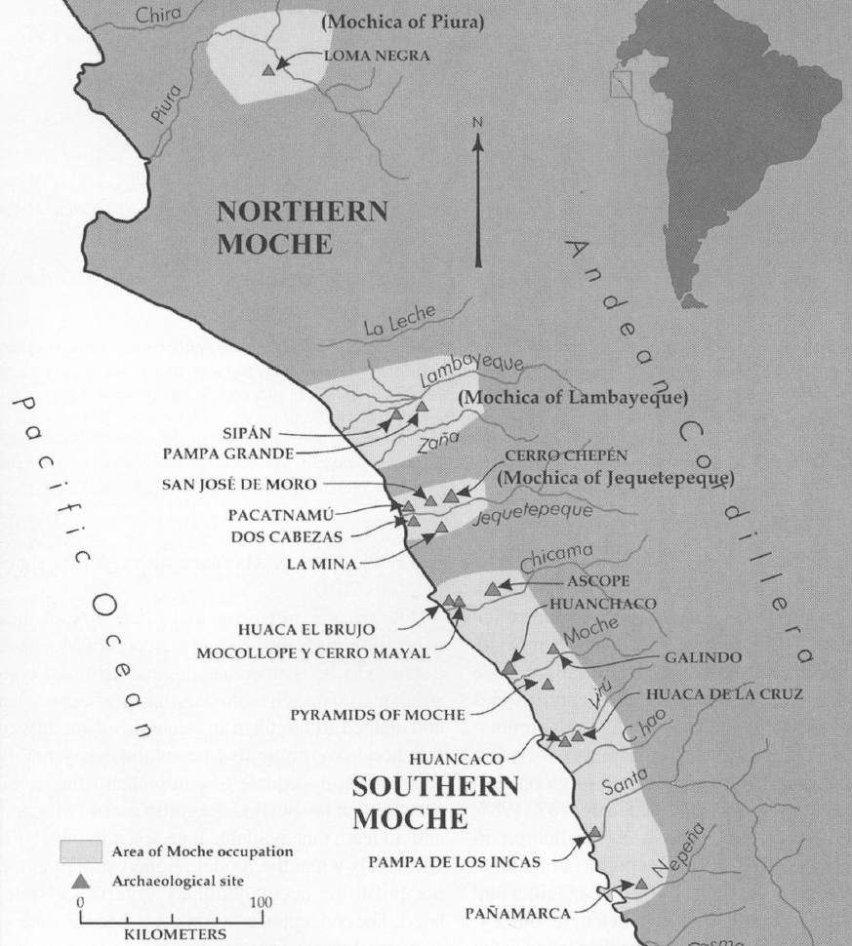

Fig. 5. Map of Moche regions as currently conceived and significant Moche sites. Map courtesy Moro Archaeological program.

**Cultural Affiliation:** Moche, Mochica

**Medium:** copper

**Dimensions:** H mm; in

**Weight: gm; oz**

**Condition: original**

**Provenance:** unknown

**Discussion:**